PHASE 8: SCREEN SHOTS

PROJECT SCREEN SHOTS
Date | 28 February 2026
Team ID | LTVIP2026TMIDS76950
Team Size | 4
Team Leader | Suresh Kumar V
Team Members | Vemanaboina Lakshmi Prasanna  Chengalaraya Akhil  Prasad Chittipothula
Project Name | HouseHunt: Finding Your Perfect Rental Home

PROJECT SCREEN SHOTS
1. Home Page:
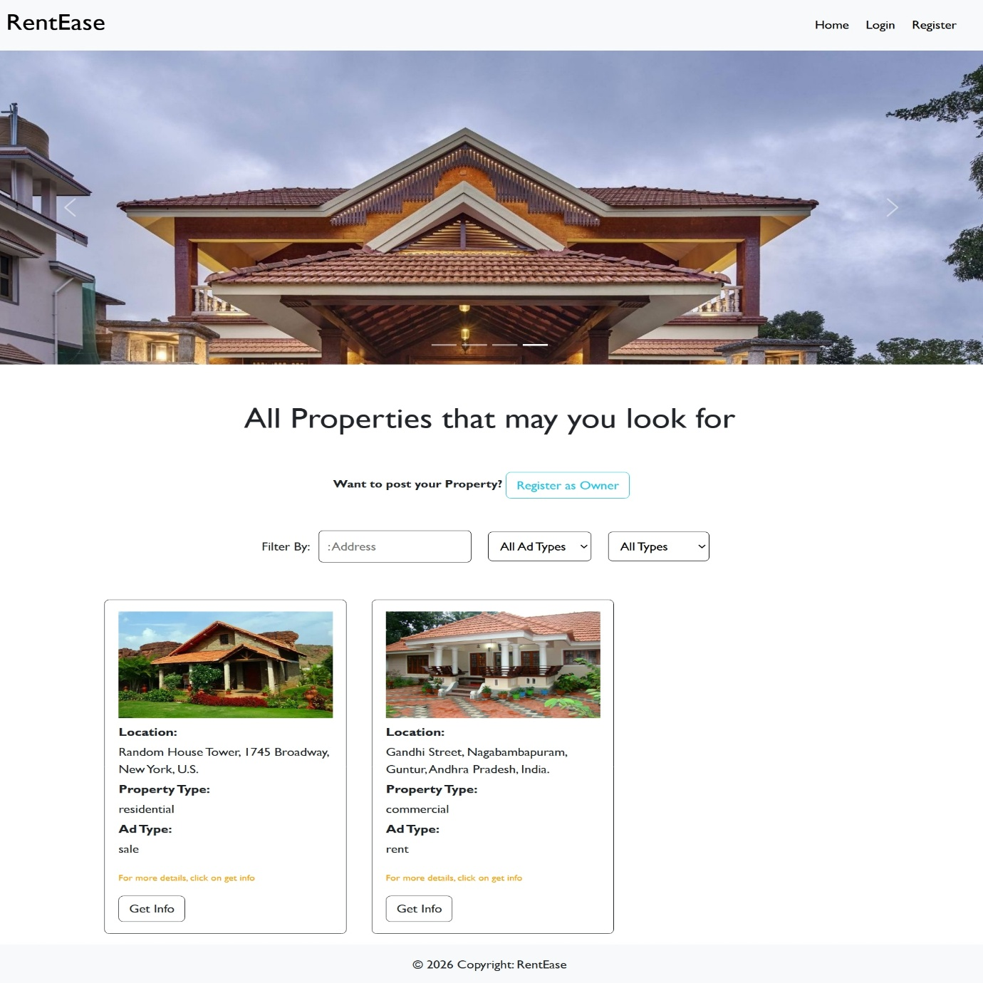
2. Register Page:
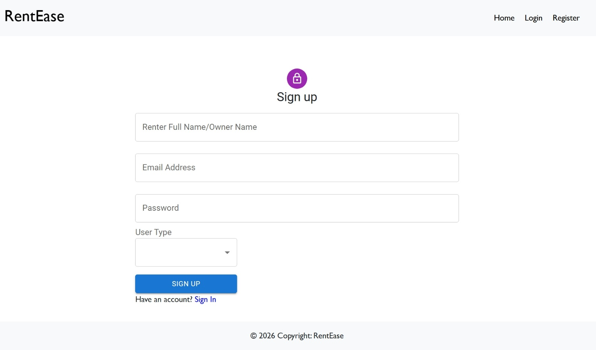

3. Login Page:
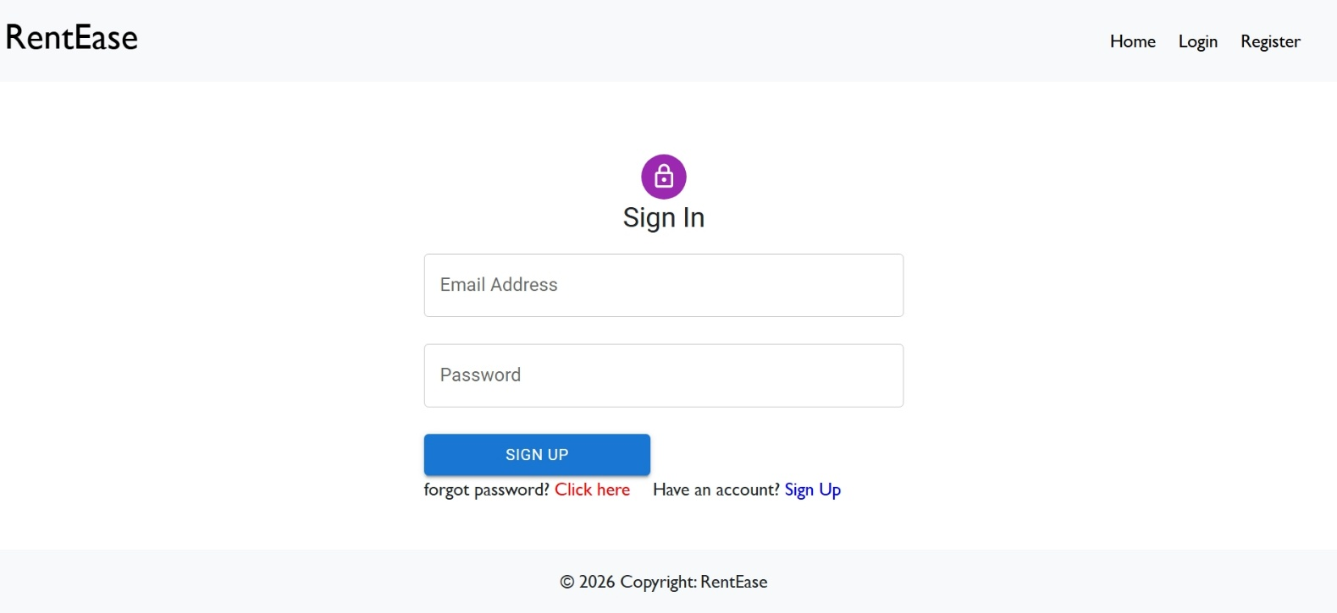

4. Admin Dashboard:

4.a. Admin Dashboard All users:

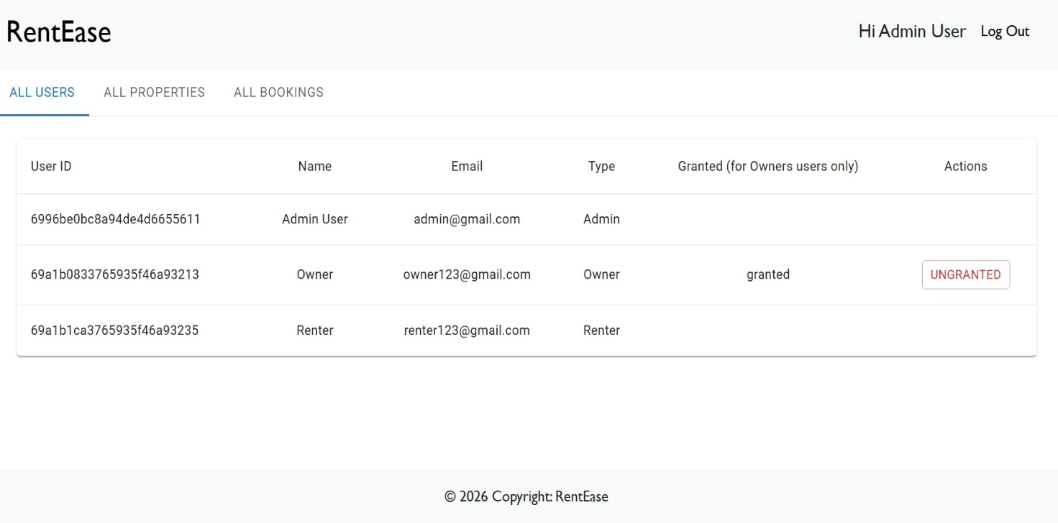
4.b. Admin Dashboard All Properties:

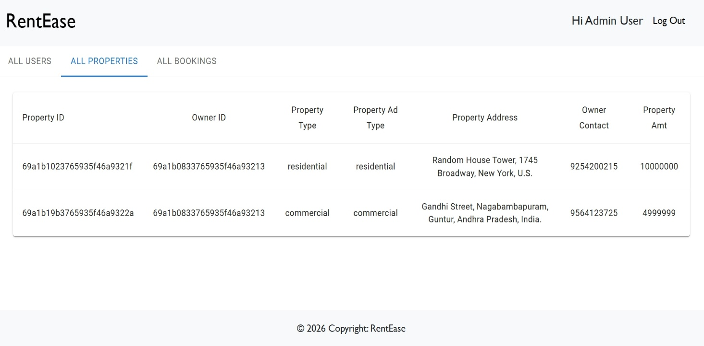

4.c. Admin Dashboard All Bookings:
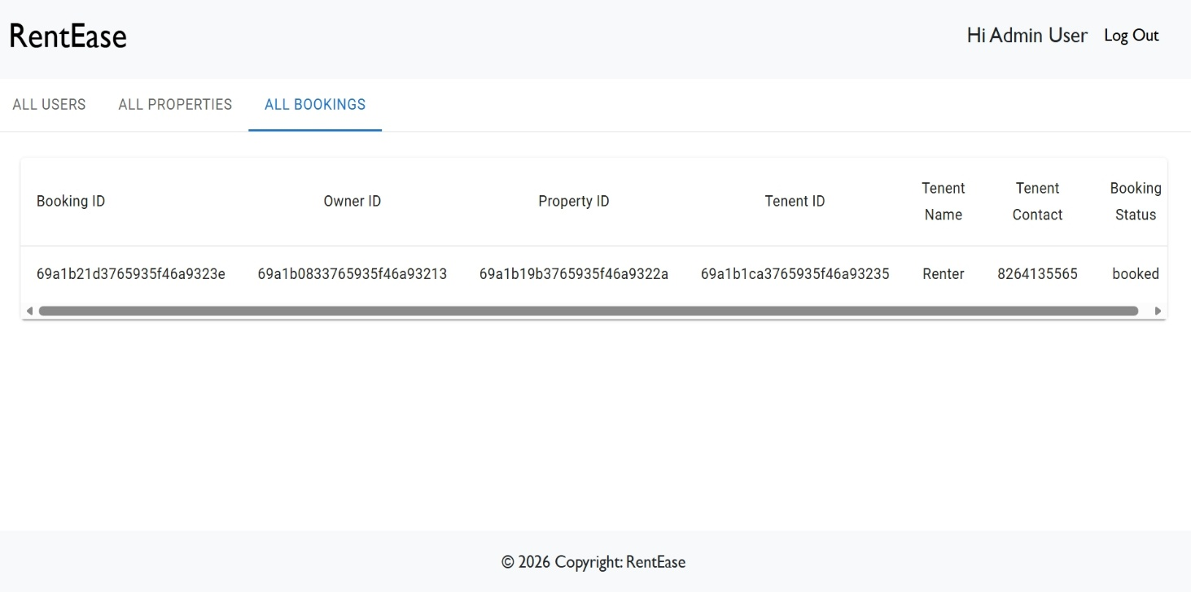

5. Owner Dashboard:

5.a. Owner Dashboard Add Properties:

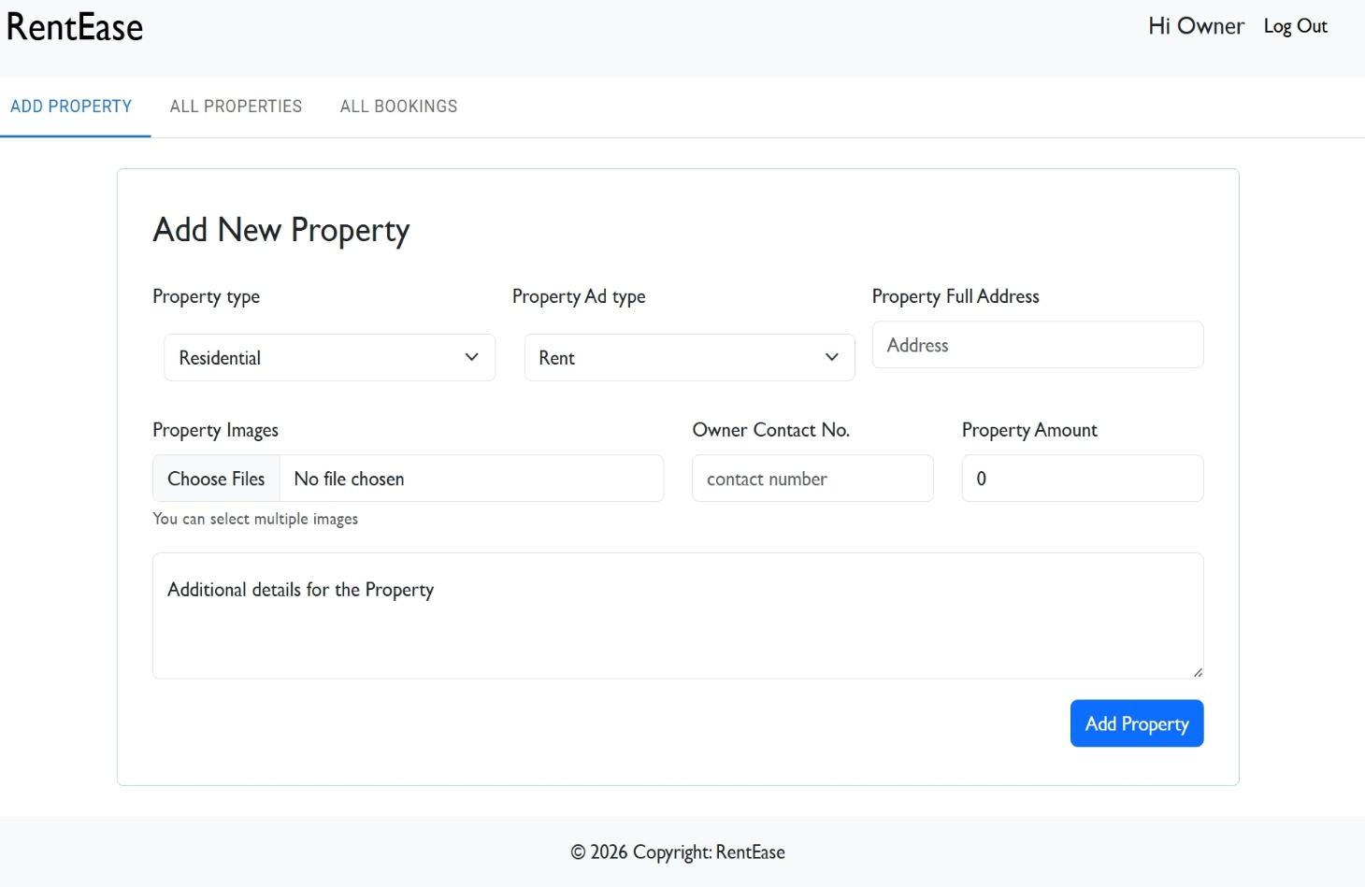

5.b. Owner Dashboard All Properties:

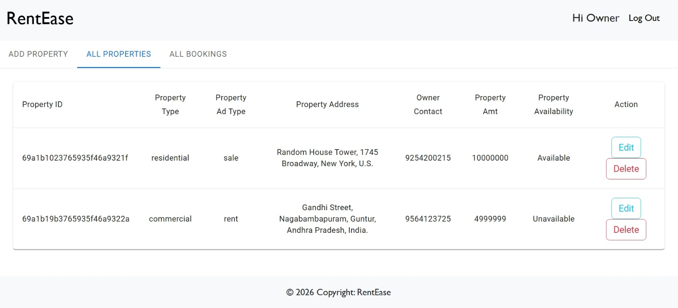

5.c. Owner Dashboard All Bookings:

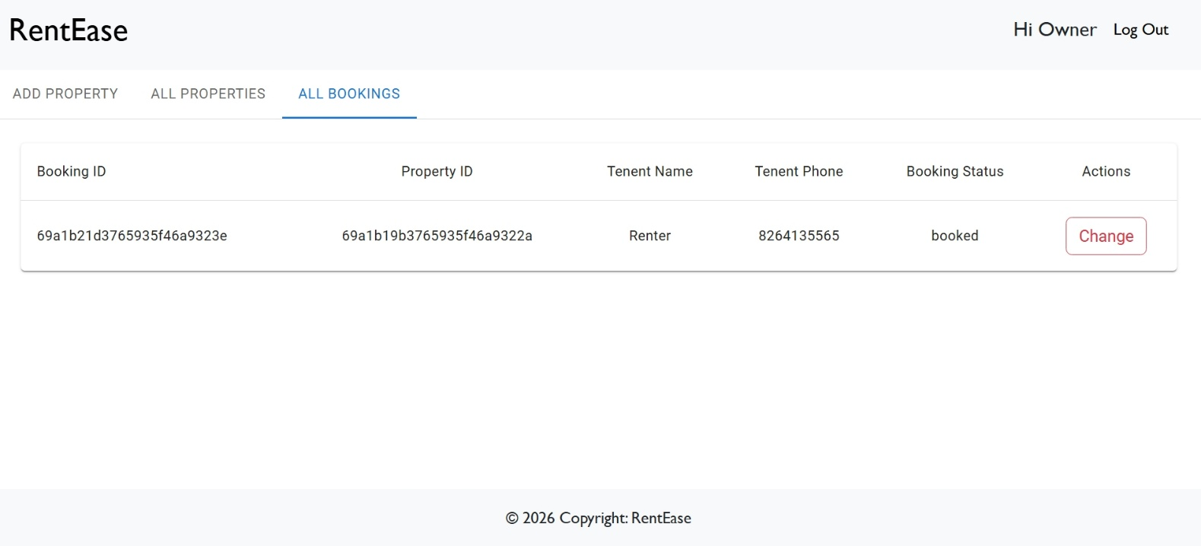

6. Renter Dashboard:
6.a. Renter Dashboard All Properties:
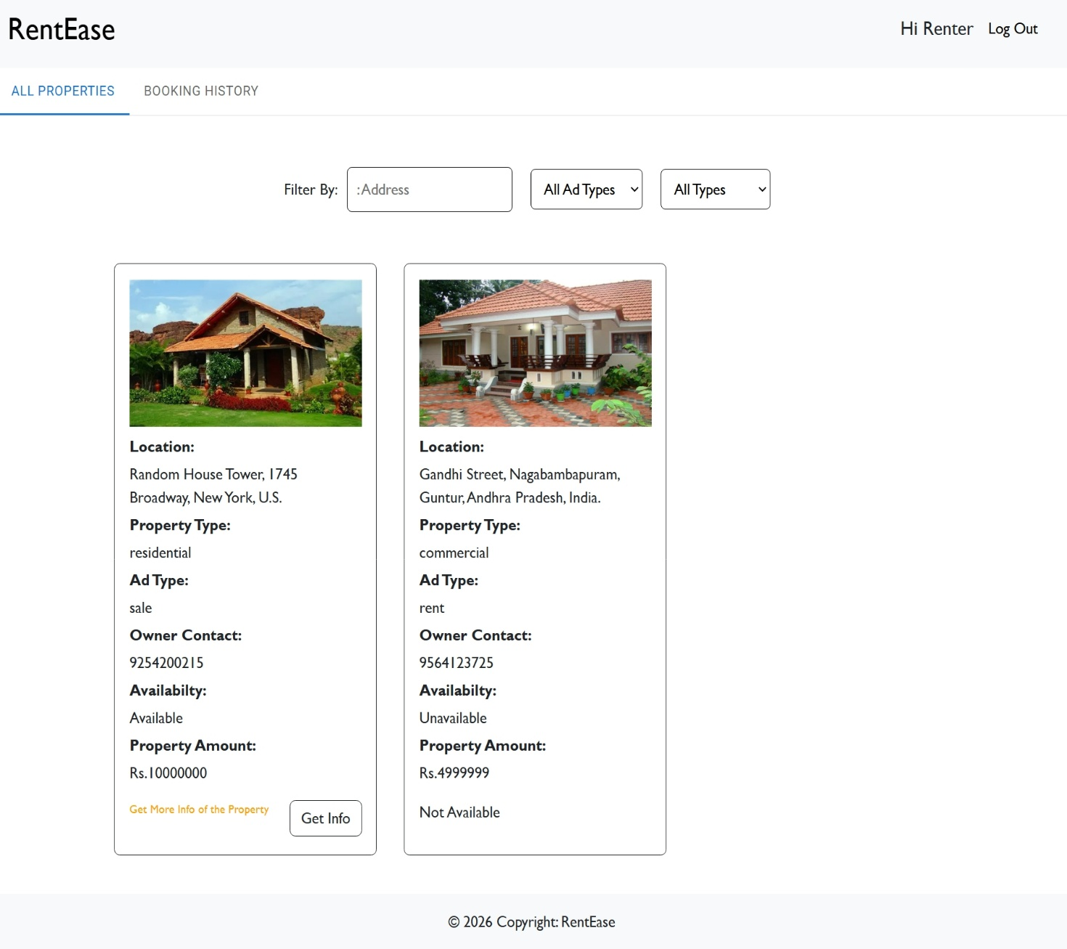
6.b. Renter Dashboard Booking History:
